NAME: | PARVENDHAN C
ROLL NO: | 241801197
DEPT: | AI&DS

- The HR department needs a list of department IDs for departments that do not contain the job ID ST_CLERK. Use set operators to create this report.
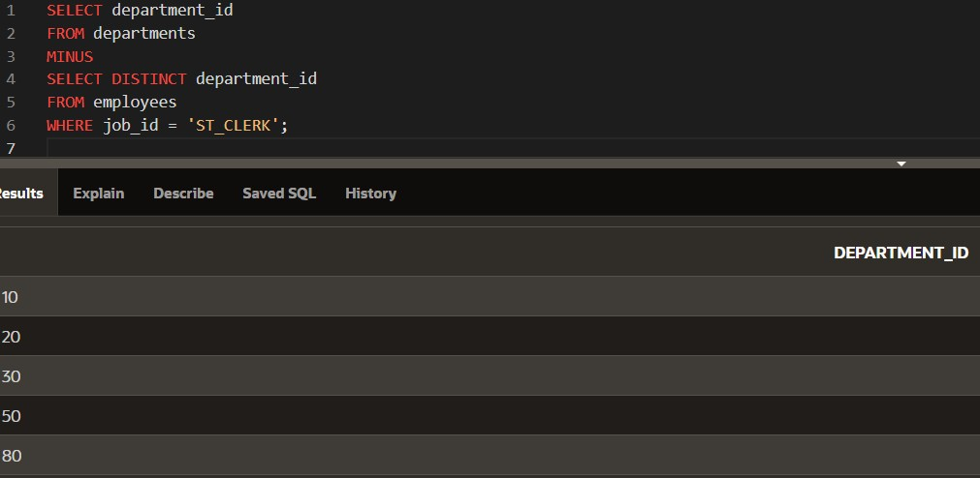

- The HR department needs a list of countries that have no departments located in them.
Display the country ID and the name of the countries. Use set operators to create this report.
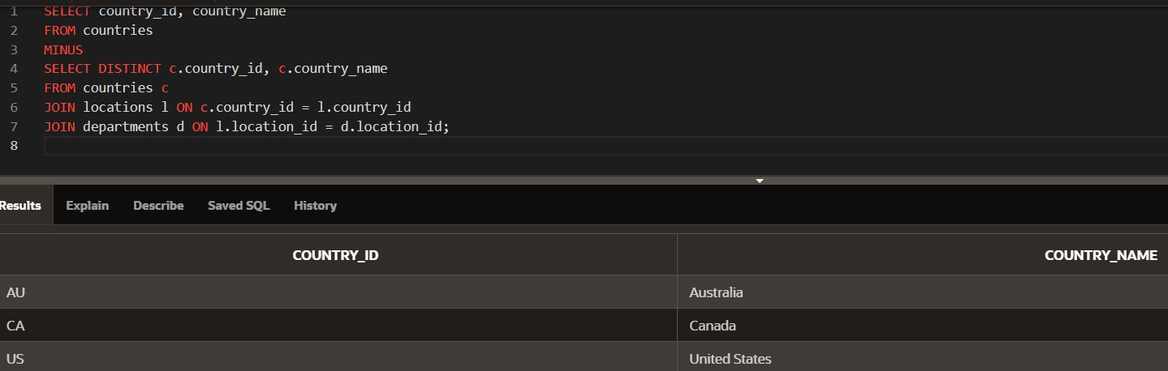

- Produce a list of jobs for departments 10, 50, and 20, in that order. Display job ID and department ID using set operators.
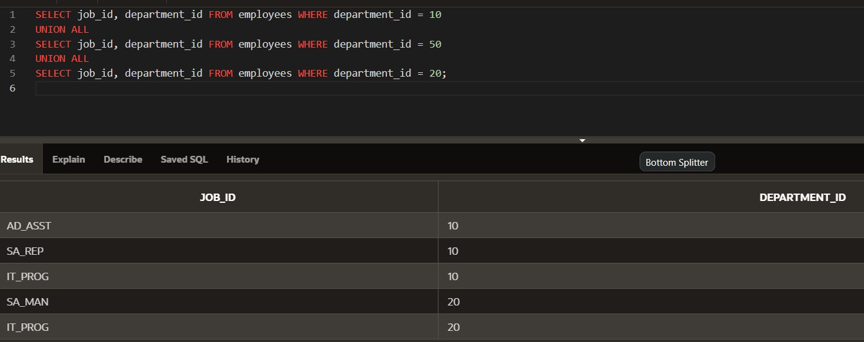

- Create a report that lists the employee IDs and job IDs of those employees who currently have a job title that is the same as their job title when they were initially hired by the company (that is, they changed jobs but have now gone back to doing their original job).
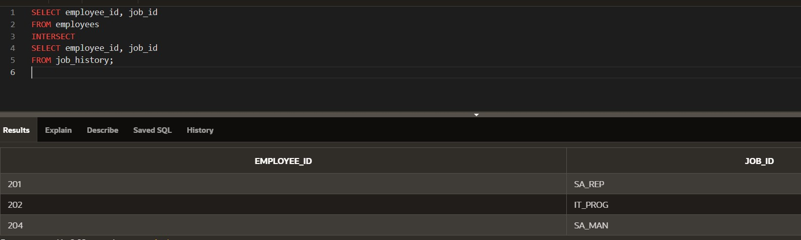

- The HR department needs a report with the following specifications:
- Last name and department ID of all the employees from the EMPLOYEES table, regardless of whether or not they belong to a department.
- Department ID and department name of all the departments from the DEPARTMENTS table, regardless of whether or not they have employees working in them Write a compound query to accomplish this.
